If the Auto Rickshaw Management System is automated, it can help improve efficiency, reduce errors, and save time for the stakeholders involved. Here are a few benefits of automation:

1. Real-time updates: An automated system can provide real-time updates on the status of Auto Rickshaws, drivers, and trips. This helps managers and owners stay informed and make better decisions.
2. Efficient resource management: An automated system can help managers optimize the allocation of resources, such as Auto Rickshaws and drivers, to meet demand. This can help reduce wait times for passengers and increase the utilization of assets.
3. Enhanced tracking and reporting: An automated system can track and report on various metrics such as the number of trips, the distance traveled, and the revenue generated. This can help managers identify trends and areas for improvement.
4. Improved communication: An automated system can facilitate better communication between stakeholders such as drivers, managers, and owners. For example, drivers can receive trip assignments directly on their mobile devices and managers can send alerts to drivers about traffic or route changes.

Overall, automation can help streamline the Auto Rickshaw Management System and make it more efficient, reliable, and profitable.

"Driver" Entity: This entity represents the driver of an Auto Rickshaw. It has attributes such as "Driver_ID", "Driver_Name", "Driver_Address", "Driver_Contact_No", "Driver_License_No", and "Auto_ID" (foreign key referencing "Auto-Rick" entity). The "Driver_ID" attribute stores a unique identifier for the driver. The "Driver_Name" attribute stores the name of the driver. The "Driver_Address" attribute stores the address of the driver. The "Driver_Contact_No" attribute stores the contact number of the driver. The "Driver_License_No" attribute stores the license number of the driver. The "Auto_ID" attribute references the "Auto-Rick" entity to associate a driver with a specific Auto Rickshaw.

"Owner" Entity: This entity represents the owner of the Auto Rickshaw. It has attributes such as "Owner_ID", "Owner_Name", "Owner_Address", "Owner_Contact_No", and "Owner_Email". The "Owner_ID" attribute stores a unique identifier for the owner. The "Owner_Name" attribute stores the name of the owner. The "Owner_Address" attribute stores the address of the owner. The "Owner_Contact_No" attribute stores the contact number of the owner. The "Owner_Email" attribute stores the email address of the owner.

"Manager" Entity: This entity represents the manager who manages the Auto Rickshaws. It has attributes such as "Manager_ID", "Manager_Name", "Manager_Address", "Manager_Contact_No", and "Manager_Email". The "Manager_ID" attribute stores a unique identifier for the manager. The "Manager_Name" attribute stores the name of the manager. The "Manager_Address" attribute stores the address of the manager. The "Manager_Contact_No" attribute stores the contact number of the manager. The "Manager_Email" attribute stores the email address of the manager.

"Auto-Rick" Entity: This entity represents the Auto Rickshaws themselves. It has attributes such as "Auto_ID", "Auto_Model", "Auto_Number", "Auto_Color", "Auto_Type", and "Auto_Status". The "Auto_ID" attribute stores a unique identifier for each Auto Rickshaw. The "Auto_Model" attribute stores the model of the Auto Rickshaw. The "Auto_Number" attribute stores the registration number of the Auto Rickshaw. The "Auto_Color" attribute stores the color of the Auto Rickshaw. The "Auto_Type" attribute stores the type of the Auto Rickshaw (such as 3-wheeler or 4-wheeler). The "Auto_Status" attribute indicates whether the Auto Rickshaw is available for use or not.

"Rounds" Entity: This entity represents the rounds that an Auto Rickshaw has completed on a particular day. It has attributes such as "Round_ID", "Auto_ID" (foreign key referencing "Auto-Rick" entity), "Start_Time", "End_Time", "Date", "Rounds", and "Status". The "Rounds" attribute stores the number of rounds completed by the Auto Rickshaw on a particular day. The "Status" attribute indicates whether the round is completed or not.

"Permission" Entity: This entity represents the permissions granted to the Auto Rickshaw to operate in a particular area. It has attributes such as "Permission_ID", "Auto_ID" (foreign key referencing "Auto-Rick" entity), "Area", "Permission_Date", "Expiry_Date", and "Status". The "Area" attribute stores the name of the area where the Auto Rickshaw is allowed to operate. The "Permission_Date" attribute stores the date when the permission was granted. The "Expiry_Date" attribute stores the date when the permission expires. The "Status" attribute indicates whether the permission is valid or not.

"Serial" Entity: This entity represents the serial number assigned to an Auto Rickshaw when it starts operating. It has attributes such as "Serial_ID", "Auto_ID" (foreign key referencing "Auto-Rick" entity), "Serial_No", "Start_Date", "End_Date", and "Status". The "Serial_No" attribute stores the serial number assigned to the Auto Rickshaw. The "Start_Date" attribute stores the date when the Auto Rickshaw started operating with the assigned serial number. The "End_Date" attribute stores the date when the Auto Rickshaw stopped operating with the assigned serial number. The "Status" attribute indicates whether the serial number is valid or not.

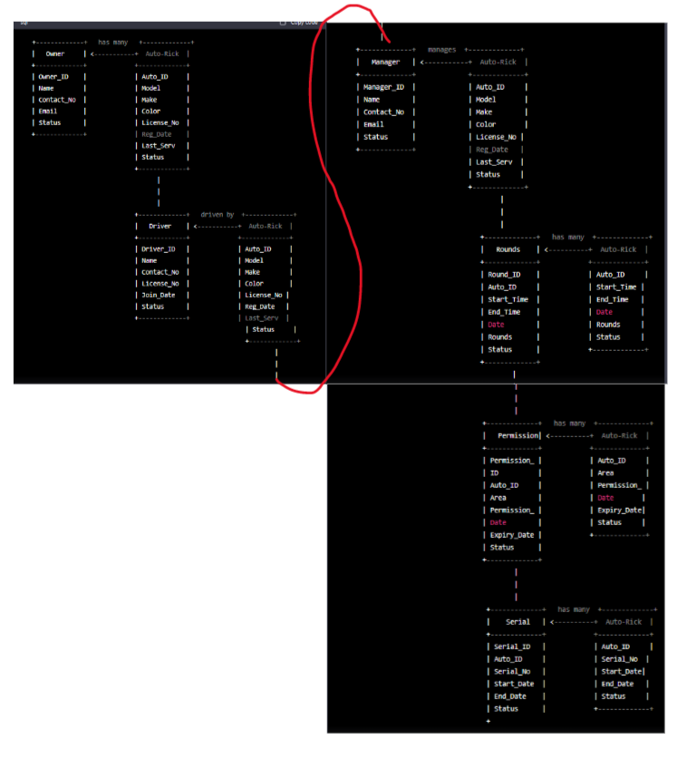

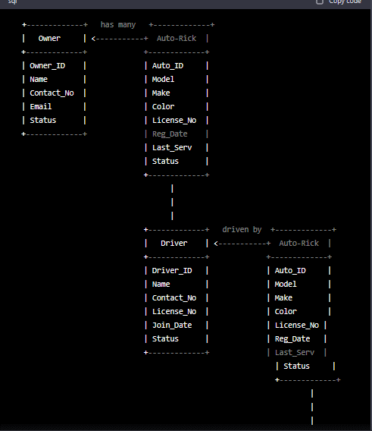

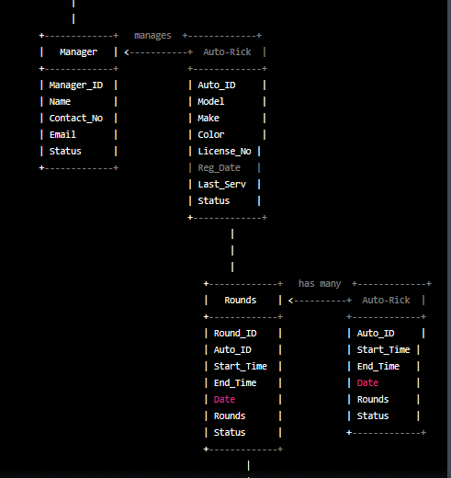

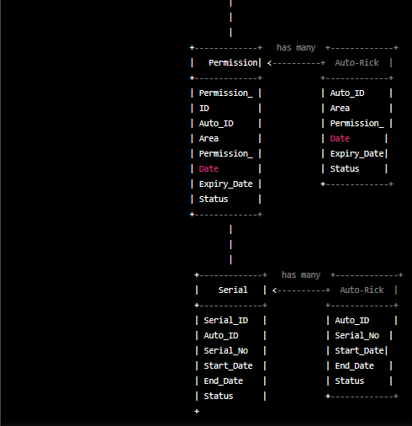

**Classes, attributes and methods:**

1. Auto-Rickshaw

* Attributes: Auto-Rickshaw ID, Model, Make, Color, License Number, Registration Date, Last Service Date, Status
* Methods: addAutoRickshaw(), updateAutoRickshaw(), deleteAutoRickshaw(), getAutoRickshawDetails()

1. Driver

* Attributes: Driver ID, Name, Contact Number, License Number, Joining Date, Status
* Methods: addDriver(), updateDriver(), deleteDriver(), getDriverDetails()

1. Customer

* Attributes: Customer ID, Name, Contact Number, Email Address, Status
* Methods: addCustomer(), updateCustomer(), deleteCustomer(), getCustomerDetails()

1. Owner

* Attributes: Owner ID, Name, Contact Number, Email Address, Status
* Methods: addOwner(), updateOwner(), deleteOwner(), getOwnerDetails()

1. Serial

* Attributes: Serial ID, Auto-Rickshaw ID, Serial Number, Start Date, End Date, Status
* Methods: addSerial(), updateSerial(), deleteSerial(), getSerialDetails()

1. Round

* Attributes: Round ID, Auto-Rickshaw ID, Round Date, Number of Rounds, Status
* Methods: addRound(), updateRound(), deleteRound(), getRoundDetails()

1. Permission

* Attributes: Permission ID, Auto-Rickshaw ID, Area, Permission Date, Expiration Date, Status
* Methods: addPermission(), updatePermission(), deletePermission(), getPermissionDetails()

1. Manager

* Attributes: Manager ID, Name, Contact Number, Email Address, Status
* Methods: addManager(), updateManager(), deleteManager(), getManagerDetails()

**Relationship between entities:**

1. An Auto-Rickshaw can have many serials but a serial can only be assigned to one Auto-Rickshaw. This is a one-to-many relationship.
2. An Auto-Rickshaw can have many rounds but a round can only be assigned to one Auto-Rickshaw. This is a one-to-many relationship.
3. An Auto-Rickshaw can have many permissions but a permission can only be assigned to one Auto-Rickshaw. This is a one-to-many relationship.
4. An Auto-Rickshaw is owned by one Owner but an Owner can have many Auto-Rickshaws. This is a many-to-one relationship.
5. A Manager can manage many Auto-Rickshaws but an Auto-Rickshaw can only be managed by one Manager. This is a many-to-one relationship.
6. A Driver can drive many Auto-Rickshaws but an Auto-Rickshaw can only be driven by one Driver. This is a many-to-one relationship.
7. A Customer can hire many Auto-Rickshaws but an Auto-Rickshaw can be hired by many Customers. This is a many-to-many relationship, which can be resolved by creating a separate entity. However, since this feature has been excluded from the system, this relationship is not modeled in the ER diagram.

want to convert the management system into a database system. Explain it details and example

Converting the Auto Rickshaw Management System into a database system can help improve data management, organization, and retrieval. Here is an overview of how a database system can be designed for the Auto Rickshaw Management System, along with an example:

1. Identify the entities: The first step is to identify the entities that need to be stored in the database. Based on the previous discussion, the entities for the Auto Rickshaw Management System are "Auto-Rick," "Driver," "Owner," "Manager," "Permission," "Serial," and "Round."
2. Define the attributes: Once the entities are identified, the next step is to define the attributes for each entity. For example, the "Auto-Rick" entity can have attributes such as "Auto_ID," "Auto_Type," "Auto_Model," "Auto_Number," and "Auto_Status." Similarly, the "Driver" entity can have attributes such as "Driver_ID," "Driver_Name," "Driver_Address," "Driver_Contact_No," "Driver_License_No," and "Auto_ID" (foreign key referencing "Auto-Rick" entity).
3. Create tables: Based on the identified entities and attributes, tables can be created in the database. For example, a table called "Auto-Rick" can be created with columns for "Auto_ID," "Auto_Type," "Auto_Model," "Auto_Number," and "Auto_Status." Similarly, a table called "Driver" can be created with columns for "Driver_ID," "Driver_Name," "Driver_Address," "Driver_Contact_No," "Driver_License_No," and "Auto_ID" (foreign key referencing "Auto-Rick" entity).
4. Establish relationships: Once the tables are created, relationships between them can be established. For example, the "Driver" table can have a foreign key referencing the "Auto-Rick" table to indicate that each driver is associated with a specific Auto Rickshaw.
5. Define constraints: Finally, constraints can be defined to ensure data integrity and consistency. For example, a constraint can be defined to ensure that each Auto Rickshaw has a unique "Auto_ID," or that each driver has a unique "Driver_ID."

Example:

Here is an example of a database schema for the Auto Rickshaw Management System:

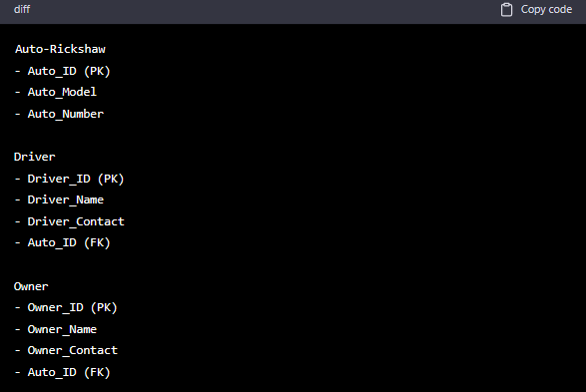

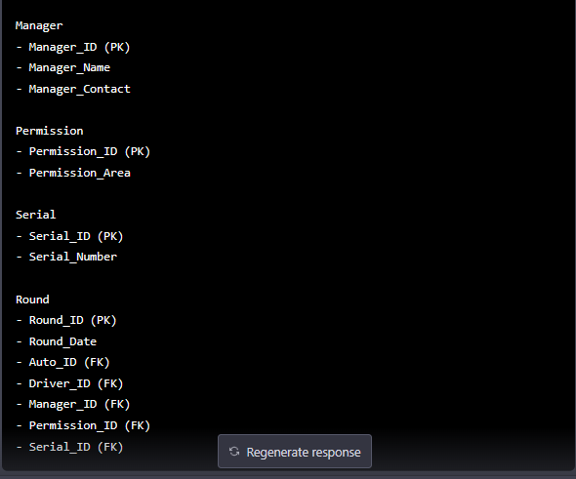

In this example, there are six tables for the entities identified earlier: "Auto-Rick," "Driver," "Owner," "Manager," "Permission," and "Serial." The tables are related to each other through foreign keys, as indicated by the arrows in the diagram.

For instance, the "Driver" table has a foreign key "Auto_ID" referencing the "Auto-Rick" table to associate each driver with a specific Auto Rickshaw. Similarly, the "Owner" table has a foreign key "Auto_ID" referencing the "Auto-Rick" table to associate each owner with a specific Auto Rickshaw.

Constraints such as primary keys, unique keys, and foreign keys have also been defined to ensure data integrity and consistency. For example, the "Auto-Rick" table has a primary key "Auto_ID" to ensure that each Auto Rickshaw has a unique identifier.

Overall, a database system can provide an efficient and reliable way to manage and store data for the Auto Rickshaw Management System.

**Schema 1:**

Entities: Auto-Rickshaw, Driver, Owner, Manager, Permission, Serial, Round

Relationships:

* One-to-many relationship between Owner and Auto-Rickshaw
* One-to-many relationship between Driver and Auto-Rickshaw
* Many-to-many relationship between Manager and Auto-Rickshaw
* Many-to-many relationship between Permission and Auto-Rickshaw
* One-to-many relationship between Serial and Auto-Rickshaw
* One-to-many relationship between Round and Auto-Rickshaw

Attributes:

Auto-Rickshaw: auto_rickshaw_id (primary key), auto_rickshaw_number, auto_rickshaw_make, auto_rickshaw_model, auto_rickshaw_color

Driver: driver_id (primary key), driver_name, driver_license_number, driver_phone_number

Owner: owner_id (primary key), owner_name, owner_phone_number, owner_address

Manager: manager_id (primary key), manager_name, manager_phone_number, manager_address

Permission: permission_id (primary key), permission_area

Serial: serial_id (primary key), serial_number, serial_date, serial_time

Round: round_id (primary key), round_date, round_start_time, round_end_time, round_start_location, round_end_location, round_fare, round_auto_rickshaw_id (foreign key)

**Schema 2:**

Entities: Auto-Rickshaw, Driver, Owner, Manager, Permission, Serial, Round

Relationships:

* One-to-many relationship between Owner and Auto-Rickshaw
* One-to-many relationship between Driver and Auto-Rickshaw
* Many-to-many relationship between Manager and Auto-Rickshaw
* Many-to-many relationship between Permission and Auto-Rickshaw
* One-to-one relationship between Auto-Rickshaw and Serial
* One-to-many relationship between Round and Serial

Attributes:

* Auto-Rickshaw: auto_rickshaw_id (primary key), auto_rickshaw_number, auto_rickshaw_make, auto_rickshaw_model, auto_rickshaw_color, serial_id (foreign key)
* Driver: driver_id (primary key), driver_name, driver_license_number, driver_phone_number
* Owner: owner_id (primary key), owner_name, owner_phone_number, owner_address
* Manager: manager_id (primary key), manager_name, manager_phone_number, manager_address
* Permission: permission_id (primary key), permission_area
* Serial: serial_id (primary key), serial_number, serial_date, serial_time, auto_rickshaw_id (foreign key)
* Round: round_id (primary key), round_date, round_start_time, round_end_time, round_start_location, round_end_location, round_fare, serial_id (foreign key)

**Schema 3:**

Entities: Auto-Rickshaw, Driver, Owner, Manager, Permission, Round

Relationships:

* One-to-many relationship between Owner and Auto-Rickshaw
* One-to-many relationship between Driver and Auto-Rickshaw
* Many-to-many relationship between Manager and Auto-Rickshaw
* Many-to-many relationship between Permission and Auto-Rickshaw
* One-to-many relationship between Round and Auto-Rickshaw

Attributes:

* Auto-Rickshaw: auto_rickshaw_id (primary key), auto_rickshaw_number, auto_rickshaw_make, auto_rickshaw_model, auto_rickshaw_color
* Driver: driver_id (primary key), driver_name, driver_license_number, driver_phone_number
* Owner: owner_id (primary key), owner_name, owner_phone_number, owner_address
* Manager: manager_id (primary key), manager_name, manager_phone_number, manager_address
* Permission: permission_id (

Sure, here are the possible database schemas for the Auto Rickshaw Management System with titles and explanations:

Auto_Rickshaw_Owner_Schema:

This schema stores information about the auto rickshaw owners, including their name, contact details, and vehicle registration number. It also maintains details about the ownership, such as the date of purchase, transfer, and expiry of ownership.

Auto_Rickshaw_Driver_Schema:

This schema stores information about the auto rickshaw drivers, including their name, contact details, and driver's license number. It also maintains details about the driver's employment, such as the date of joining, termination, and salary.

Auto_Rickshaw_Schema:

This schema stores information about the auto rickshaws, including their make, model, year of manufacture, seating capacity, and fuel type. It also maintains details about the vehicle's condition, such as the date of servicing, repairs, and inspections.

Auto_Rickshaw_Trip_Schema:

This schema stores information about the trips made by the auto rickshaws, including the start time, end time, distance covered, and fare charged. It also maintains details about the trip's origin and destination, such as the pickup and drop-off locations.

Auto_Rickshaw_Route_Schema:

This schema stores information about the routes used by the auto rickshaws, including the start and end locations, distance, and estimated travel time. It also maintains details about the route's traffic conditions and landmarks.

Auto_Rickshaw_Permission_Schema:

This schema stores information about the permissions granted to the auto rickshaw drivers to operate in certain areas, including the date, time, and duration of the permission. It also maintains details about the authorized areas and the authorities who granted the permission.

Auto_Rickshaw_Manager_Schema:

This schema stores information about the auto rickshaw managers, including their name, contact details, and managerial roles. It also maintains details about the managerial tasks, such as the assignment of drivers, auto rickshaws, and routes.

**Auto_Rickshaw_Owner_Schema:**

CREATE TABLE auto_rickshaw_owner (

id INT NOT NULL AUTO_INCREMENT,

name VARCHAR(50) NOT NULL,

phone_number VARCHAR(20) NOT NULL,

email VARCHAR(50),

address VARCHAR(100),

vehicle_registration_number VARCHAR(20) NOT NULL UNIQUE,

date_of_purchase DATE,

date_of_transfer DATE,

date_of_expiry DATE,

PRIMARY KEY (id)

);

**Auto_Rickshaw_Driver_Schema:**

CREATE TABLE auto_rickshaw_driver (

id INT NOT NULL AUTO_INCREMENT,

name VARCHAR(50) NOT NULL,

phone_number VARCHAR(20) NOT NULL,

email VARCHAR(50),

address VARCHAR(100),

driver_license_number VARCHAR(20) NOT NULL UNIQUE,

date_of_joining DATE,

date_of_termination DATE,

salary DECIMAL(10, 2),

PRIMARY KEY (id)

);

**Auto_Rickshaw_Schema:**

CREATE TABLE auto_rickshaw (

id INT NOT NULL AUTO_INCREMENT,

make VARCHAR(50) NOT NULL,

model VARCHAR(50) NOT NULL,

year_of_manufacture INT NOT NULL,

seating_capacity INT NOT NULL,

fuel_type VARCHAR(20) NOT NULL,

registration_number VARCHAR(20) NOT NULL UNIQUE,

condition VARCHAR(50),

date_of_service DATE,

date_of_repairs DATE,

date_of_inspection DATE,

PRIMARY KEY (id)

);

**Auto_Rickshaw_Trip_Schema:**

CREATE TABLE auto_rickshaw_trip (

id INT NOT NULL AUTO_INCREMENT,

auto_rickshaw_id INT NOT NULL,

start_time DATETIME NOT NULL,

end_time DATETIME NOT NULL,

distance_covered DECIMAL(10, 2) NOT NULL,

fare_charged DECIMAL(10, 2) NOT NULL,

pickup_location VARCHAR(100) NOT NULL,

dropoff_location VARCHAR(100) NOT NULL,

PRIMARY KEY (id),

FOREIGN KEY (auto_rickshaw_id) REFERENCES auto_rickshaw(id)

);

**Auto_Rickshaw_Route_Schema:**

CREATE TABLE auto_rickshaw_route (

id INT NOT NULL AUTO_INCREMENT,

start_location VARCHAR(100) NOT NULL,

end_location VARCHAR(100) NOT NULL,

distance DECIMAL(10, 2) NOT NULL,

estimated_travel_time INT NOT NULL,

traffic_conditions VARCHAR(50),

landmarks VARCHAR(100),

PRIMARY KEY (id)

);

**Auto_Rickshaw_Permission_Schema:**

CREATE TABLE auto_rickshaw_permission (

id INT NOT NULL AUTO_INCREMENT,

auto_rickshaw_driver_id INT NOT NULL,

start_time DATETIME NOT NULL,

end_time DATETIME NOT NULL,

duration INT NOT NULL,

authorized_area VARCHAR(100) NOT NULL,

granted_by VARCHAR(50) NOT NULL,

PRIMARY KEY (id),

FOREIGN KEY (auto_rickshaw_driver_id) REFERENCES auto_rickshaw_driver(id)

);

**Auto_Rickshaw_Manager_Schema:**

CREATE TABLE auto_rickshaw_manager (

id INT NOT NULL AUTO_INCREMENT,

name VARCHAR(50) NOT NULL,

phone_number VARCHAR(20) NOT NULL,

email VARCHAR(50),

address VARCHAR(100),

managerial_role VARCHAR(50) NOT NULL,

PRIMARY KEY (id)

);

The steps involved in the Auto Rickshaw Management System:

1. Owner registration: The system allows auto-rickshaw owners to register their vehicles by providing personal information and vehicle details, such as the registration number, model, and make.
2. Driver registration: Once the owner registers, the system allows them to register their drivers by providing their personal information, license details, and other necessary information.
3. Route Management: The system provides a feature to add and manage routes, which can be used by drivers to pick up and drop off passengers.
4. Allocation of Vehicles: Once the owner and drivers are registered, the system automatically assigns a vehicle to a driver based on availability and preference.
5. Trip Management: The system allows drivers to log in and record their trips, including start time, end time, pick-up, and drop-off locations.
6. Tracking: The system provides real-time tracking of vehicles using GPS technology. This feature enables the owners to track their vehicles' location, speed, and other details.
7. Revenue Management: The system also helps manage revenue by keeping track of each driver's earnings, commission, and expenses.
8. Reports: The system generates various reports, including trip reports, driver performance reports, and revenue reports, to help owners make informed decisions.
9. Overall, the Auto Rickshaw Management System streamlines the management of auto-rickshaws, making it easier for owners to manage their vehicles and drivers and providing a better experience for passengers.

**Here's an updated step-by-step process that includes**

1. **Owner Registration: The first step in the process is for auto-rickshaw owners to register** their vehicles in the system. Owners need to provide their personal information, such as name, address, and contact details, along with their vehicle details, such as the registration number, make, and model.
2. Driver Registration: Once the owner is registered, they can register their drivers in the system. Drivers need to provide their personal information, including name, address, and contact details, along with their driving license details.
3. Permission Management: The system allows the owner to manage the permissions granted to drivers, such as the areas they can operate in and the hours they can work. The owner can also manage the permissions granted to managers, such as access to driver and revenue data.
4. Manager Registration: The owner can also register managers who will oversee the drivers and vehicles. Managers need to provide their personal information, including name, address, and contact details, along with their designation and responsibilities.
5. Vehicle Allocation: Once the owner, driver, and manager are registered, the system automatically assigns a vehicle to a driver based on availability and preference.
6. Route Management: The next step is to manage the routes for the auto-rickshaws. Owners can add and manage routes in the system, which can be used by drivers to pick up and drop off passengers.
7. Trip Management: Once the vehicle is allocated, the driver can log in to the system and start recording their trips. They need to enter details such as start time, end time, pick-up location, and drop-off location for each trip.

Overall, the Auto Rickshaw Management System helps owners manage their vehicles, drivers, managers, permissions, routes, and revenue, making it easier for them to run a profitable business while providing a better experience for passengers.